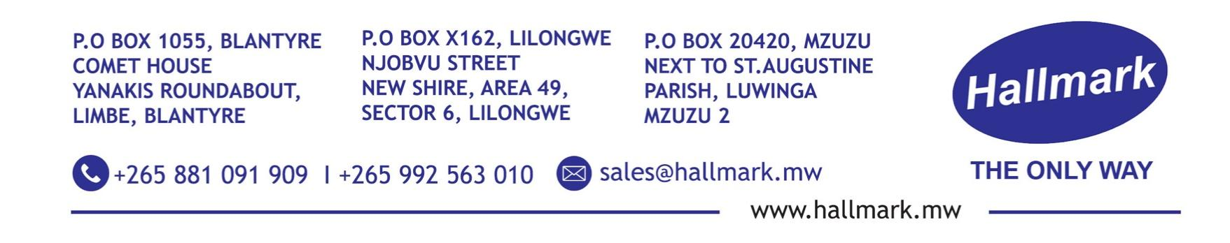

Hallmark Limited – Industrial Business Unit

Business Profile | 2026 Edition

Overview

Hallmark Limited’s Industrial Business Unit delivers engineering, maintenance, and infrastructure solutions that keep industrial, utility, and commercial operations running safely, efficiently, and in compliance with international standards.

We combine hands-on engineering expertise with disciplined project delivery to provide equipment servicing, fabrication, electrical and mechanical installations, and energy and water systems that reduce downtime, extend asset life, and lower operating costs.

Operating across Malawi and Zambia, we serve manufacturing, mining, agro-processing, water utilities, healthcare, and government infrastructure projects. Our solutions are designed for African operating conditions but built to IEC, SABS, and ISO standards—making them bankable for DFIs, multinationals, and donor-funded programs.

Our Vision

To be Sub-Saharan Africa’s trusted partner for industrial engineering and maintenance solutions that maximize uptime, safety, and operational efficiency.

Our Mission

To deliver reliable, cost-effective industrial services through certified engineering, rigorous processes, and responsive lifecycle support.

Core Services

1. Maintenance, Repair & Fabrication

- We maintain and restore critical assets to extend service life and prevent unplanned shutdowns.

- Generator diagnostics, servicing, and load testing up to 2MVA

- AC/DC motor rewinding, balancing, and vibration analysis

- Certified welding: MIG, TIG, and arc welding for structural and pressure applications

- Preventive and predictive maintenance programs tailored to equipment and environment

- Mechanical maintenance for pumps, compressors, gearboxes, and material handling systems

- Electrical & Structural Installations

Turnkey design and installation of industrial infrastructure.

- MV/LV electrical reticulation, switchgear, and distribution boards to IEC standards

- Aluminium and steel fabrication: windows, doors, partitions, security fittings

- Kiosks, site offices, modular structures, and warehouse installations

- Structural steelwork, conveyor systems, and site infrastructure

- Energy & Power Solutions

Power systems that reduce cost, improve reliability, and support ESG goals.

- Solar PV design, EPC, and O&M for grid-tied and off-grid systems

- Hybrid systems, inverters, battery storage, and UPS for mission-critical loads

- Smart energy metering and remote monitoring platforms

- HV transmission hardware, conductors, insulators, and smart grid components

- Energy audits and load optimization for cost reduction

- Water & Process Systems

End-to-end water management for industrial and utility clients.

- Industrial and submersible water pumps, booster systems, and controls

- High-accuracy smart water meters with AMI/AMR and remote monitoring

- Durable piping, fittings, and leak-proof jointing systems for potable and process water

- Chemical dosing, water treatment, and filtration systems

- Automation & Facility Controls

Control systems that improve efficiency, safety, and compliance.

- PLC programming and SCADA integration for Siemens, Schneider Electric, and Allen-Bradley platforms

- Energy management and load optimization systems

- Environmental controls for temperature, humidity, and air quality in labs and production

- Industrial automation for production lines, water treatment, and utility systems

Our Project Delivery Process

- Assess & Diagnose: Site inspection, condition monitoring, and root cause analysis to identify operational risks.

- Engineer & Design: Solutions engineered to your operating conditions, budget, and regulatory requirements using PVsyst, AutoCAD, and EPLAN.

- Execute & QA: Certified technicians execute to specification with documented quality checks, FAT, and SAT protocols.

- Commission & Train: System commissioning, performance validation, and hands-on training for your operations and maintenance teams.

- Support & Optimize: SLA-backed maintenance, rapid response repairs, spare parts management, and remote monitoring to minimize downtime.

Technical Capabilities & Standards

- Electrical/Mechanical: Design and execution for LV and MV systems up to 33kV

- Welding: Certified welders to ASME and SABS standards

- Automation: PLC/SCADA programming, HMI development, and field instrumentation

- Renewable Energy: Solar system design using PVsyst and HelioScope; hybrid system integration

- Compliance: Work executed to IEC, SABS, SADC, and local building and energy codes

- Facilities: Workshops in Blantyre and Lusaka equipped for machining, fabrication, testing, and calibration

What Sets Us Apart

- Field-Proven, Bankable Solutions

Our engineers work on live systems daily. We design for maintainability, spare parts availability, and real-world conditions—no stranded assets.

- Regional Presence, Fast Response

Workshops and technical teams in Blantyre, Lilongwe, and Lusaka enable 24-72 hour response across Malawi and Zambia, reducing MTTR and travel costs.

- EPC & Project Management Capability

Single-point accountability from feasibility and design through procurement, construction, commissioning, and handover. We manage subcontractors, safety, and QA to meet donor and corporate standards.

- ESG & Sustainability Focus

Solutions target energy efficiency, water loss reduction, and carbon footprint reduction. Our solar and smart metering projects directly support SDG 6, 7, and 9.

- Safety & Compliance First

All work follows ISO 45001-aligned HSE protocols. We provide risk assessments, method statements, permits-to-work, and full as-built documentation for audits and insurance.

Industries We Serve

- Manufacturing, agro-processing, and FMCG
- Water utilities and irrigation projects
- Mining and construction support services
- Healthcare facilities and laboratories
- Commercial buildings, retail, and logistics
- Government and NGO infrastructure programs

Client Outcomes

Clients partnering with our Industrial unit typically achieve:

- 30-50% reduction in unplanned downtime through preventive maintenance programs

- 15-30% energy cost reduction via motor efficiency upgrades and solar integration

- Extended asset life through proper servicing, lubrication, and condition monitoring

- Improved regulatory compliance with documented HSE and quality records

Quality, HSE & Documentation

Every project follows a documented Quality and HSE Plan. Materials are sourced from approved suppliers with traceability. We provide test certificates, FAT/SAT reports, as-built drawings, O&M manuals, and training records on handover to support audits and financing requirements.

Contact

Hallmark Limited – Industrial Business Unit
Email: industrial@hallmark.mw
Website: www.hallmark.mw
Phone: +265 881 091 909 | +265 992 563 010
WhatsApp: +265 881 091 909

Head Office – Malawi
Area 47, Sector 1, Nzinziri Street,
- O. Box 162, Lilongwe, Malawi

Zambia Office
Plot 160, Silverest, Lusaka, Zambia

Regional Office – Blantyre
Comet House, Yanakis Roundabout, Limbe, Blantyre, Malawi

THE ONLY WAY

